LOGAN CARDIOLOGY AND SPECIALIST CENTRE

24 Hour Blood Pressure Monitor
Patient information for the WBP 02A
Wear your ambulatory blood pressure monitor (ABPM) for the full 24 hours as instructed. It measures your blood pressure during your usual daily activities and sleep.
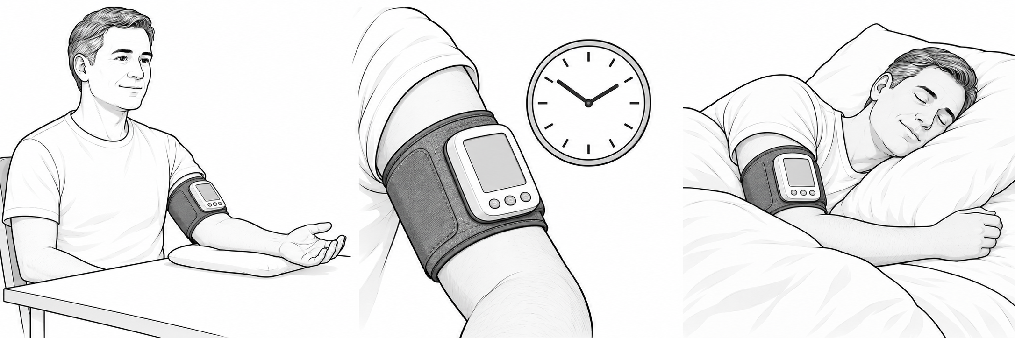
KEEP YOUR ARM STILL AUTOMATIC READINGS WEAR DURING SLEEP

How does ABPM work
Staff fit a cuff around your upper arm and check a first reading. The WBP-02A recorder sits directly on the cuff, without a long external tube. The cuff automatically inflates, briefly squeezes your arm, then deflates. Each reading is saved for your cardiologist to review.

How often will my blood pressure be taken
Often every 30 minutes during the day and every 60 minutes at night. Staff can programme different intervals and will confirm yours. The cuff may inflate again if a reading is unsuccessful. Night readings may briefly disturb sleep.
Your schedule Day every ______ minutes Night every ______ minutes

Patient do’s
- Continue your usual routine and prescribed medicines unless your clinician advises otherwise. Wear loose clothing and keep the cuff in place for the full test.
- When the cuff inflates, pause safely, keep quiet and relax your arm and hand. Support the arm near heart level where practical; keep it still until the cuff deflates.
- Record sleep and waking times, medicines, activities and symptoms in your diary, with the time they occurred.
- Undress carefully at bedtime without disturbing the cuff or recorder. If tubing is present, keep it connected and free of kinks. Support your arm comfortably while sleeping.

Patient don’ts
- Do not shower, bathe or swim while wearing the monitor. Keep the cuff and recorder dry.
- Avoid strenuous exercise and heavy lifting. Do not clench your fist or move or bend your arm during a reading.
- Do not remove the cuff early, switch off, change settings, charge the recorder or repeatedly press buttons unless instructed.

Controls and comfort
Staff will explain and check the controls. When enabled, pressing Start/Stop during a reading cancels it and deflates the cuff. Do not hold the button down, as a long press can switch the recorder off.
Brief tightness is expected. If the cuff causes severe or persistent pain, numbness, swelling or a cold or discoloured hand, stop the reading. If it does not deflate, remove the cuff and contact the clinic promptly. Contact staff if the cuff slips or readings repeatedly fail.
After 24 hours: Return the monitor and diary at the arranged time. Follow staff instructions for removal. Your cardiologist will review the results.
Emergency: For severe chest pain, severe breathlessness or collapse, call 000. Do not wait for the monitor or results.
Clinic contact ____________________ Return date and time ____________________

