LOGAN CARDIOLOGY AND SPECIALIST CENTRE

Transthoracic Echocardiogram
Patient information
A transthoracic echocardiogram (TTE or echo) is an ultrasound scan of your heart. It uses sound waves to show your heart’s structure, pumping function, valves and blood flow. It can also show fluid around the heart.
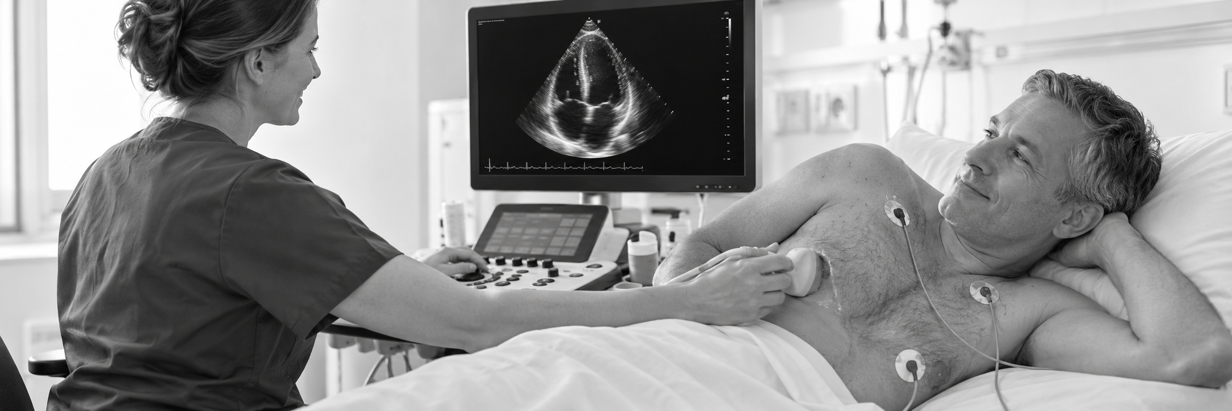

Before your appointment
No fasting is usually needed. Eat, drink and take your usual medicines unless your doctor advises otherwise. Wear a top that is easy to remove. Tell staff about skin sensitivities, mobility needs or interpreter requirements.

During the scan
You will remove clothing above the waist and be offered a gown or covering. Small sticky ECG electrodes are placed on your chest to monitor your heart rhythm. You will lie on your left side or back while the sonographer applies gel and moves a handheld probe over your chest. You may be asked to change position or briefly hold your breath. The scan usually takes 30–45 minutes.

Your comfort and privacy
The gel may feel cool, and pressure from the probe may cause mild discomfort. Gel or sticky electrodes may occasionally irritate your skin. Tell staff if you feel uncomfortable or need a break. Your privacy will be respected, and you may request a chaperone. You can ask questions or ask for the scan to stop at any time.

After the scan and your results
The gel is wiped off and the electrodes are removed. You can usually return to normal activities straight away. Your cardiologist reviews the images, and the results will be discussed with you or your referring doctor. Image quality can vary, and further tests may sometimes be needed.
This guide describes a standard TTE. staff will explain separately and seek your consent.

