LOGAN CARDIOLOGY AND SPECIALIST CENTRE

24 Hour Vine Holter Monitor
Patient information and care guide
Wear your monitor for the full 24 hours as instructed. It records your heartbeat during daily activities and sleep to help your cardiologist assess your heart rhythm.
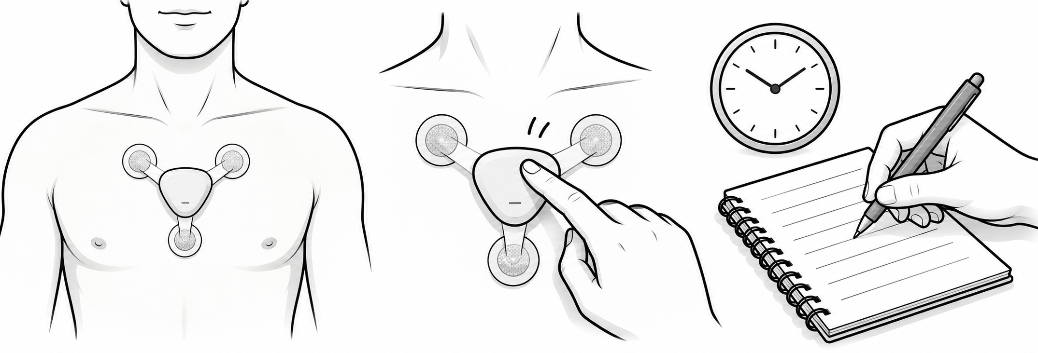
WEAR THE MONITOR DOUBLE TAP FOR SYMPTOMS WRITE IN YOUR DIARY

How it works and what to expect
Three sticky electrodes on your chest detect the electrical signals from your heart. The small wireless Vine device records these signals continuously. Staff clean and dry your skin and may remove chest hair before fitting it. Fitting is usually painless; the stickers may cause mild skin irritation.

What to do
- Keep the monitor attached, including while sleeping. Continue your usual daily routine and medicines unless your clinician advises otherwise.
- If you feel palpitations, dizziness, chest discomfort or breathlessness, firmly double-tap the device once per episode. Green, yellow and red lights confirm the event marker.
- Write the date, time, symptom, duration and what you were doing in your diary. The recording continues even when you have no symptoms.
- Vine permits short showers of about 15 minutes or less. Avoid hot water and soap on the device; gently pat it dry afterwards. Follow any additional clinic instructions.

What to avoid
- Do not swim, soak in a bath or submerge the device. Do not pull at it or remove it early unless instructed or you develop an allergic reaction.
- Do not have MRI, CT or similar imaging during the test without first arranging this with the clinic and imaging team. Do not change or charge the battery yourself.

Lights and skin care
Flashing green: recording (twice every 2 seconds initially, then once). Yellow or green with yellow: low battery; recording continues. Contact the clinic for advice. Solid red: contact the clinic. Red flashing every 2 seconds: the recording period has finished.
If a sticker loosens or mild itching occurs, contact the clinic; replace electrodes only as shown, using the supplied spares on dry skin in the same area. For an allergic reaction, remove the patch, stop using it and seek medical advice promptly.
Emergency: For severe chest pain, severe difficulty breathing or collapse, call 000. Do not wait for test results. This recorder does not provide emergency treatment.
After 24 hours: Follow staff instructions for removal. Return the monitor and diary at the arranged time; your cardiologist will review the results.
Clinic contact ____________________ Return date and time ____________________
Based on the supplied CardioScan Vine fitting guide, light guide and patient diary (A002 and AU_A082). Illustration is schematic. General information: Royal Papworth Hospital ECG Holter Monitoring leaflet.

