LOGAN CARDIOLOGY AND SPECIALIST CENTRE

Stress Echocardiogram Test
Patient information for an exercise stress echo
A stress echo combines heart ultrasound with treadmill exercise. It helps assess how your heart pumps and investigate chest pain, breathlessness or reduced blood supply to the heart. Allow 45–60 minutes, plus any extra recovery time advised by staff.
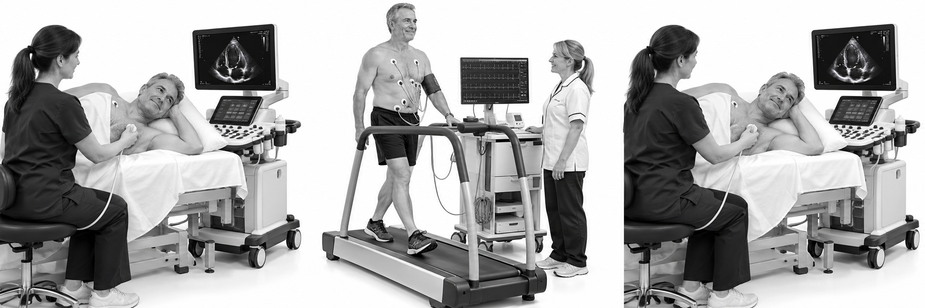
1 Scan at rest → 2 Supervised exercise → 3 Scan and recovery

Before your appointment
Food and drinks Avoid food for 2–3 hours and caffeine and tobacco for 3 hours beforehand. Stay hydrated unless you have a fluid restriction. Follow any specific clinic instructions.
Clothing and medicines Wear comfortable clothes and enclosed walking shoes. Bring your medication list. Continue usual medicines unless your cardiologist advises otherwise. Do not stop medicines yourself.
Tell us beforehand Tell staff about diabetes, allergies, recent illness or difficulty walking. Ask about diabetes medicines when avoiding food.

What happens during the test
Preparation A gown or drape protects your privacy while your chest is accessed. You may request a chaperone. Sticky ECG electrodes and an arm cuff monitor your heart rhythm and blood pressure.
Scan and exercise You lie on your side while a probe and gel are placed on your chest. You then walk on a treadmill that gradually becomes faster and steeper under cardiologist supervision. You lie down again for a scan immediately after exercise.

Speak up during the test
Tell staff immediately Report chest pain, marked breathlessness, dizziness, palpitations or feeling unwell. You may ask to stop at any time. Wait until the treadmill stops before stepping off.
Possible risks Tiredness, breathlessness, dizziness or discomfort may occur. Less commonly, fainting or abnormal heart rhythms occur. Serious complications, including a heart attack, are rare; death is extremely rare. Trained staff and emergency equipment are available.

After the test
Recovery and results Stay for monitored recovery and, if advised, another 20–30 minutes in the waiting room. Leave when staff say it is safe. Follow their activity advice. Your report goes to your referring doctor. A normal result does not exclude all coronary artery disease.
Questions before your appointment? Call 07 3200 2900.
This guide supports the discussion with your clinical team and does not replace consent.

